RECOMMENDED HOTELS

HOTEL MAKEDONIA PALACE

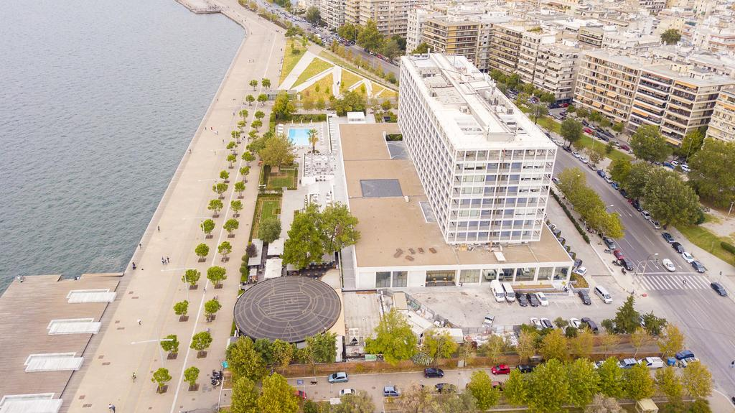

Address: | Av. Alexander the Great 2  54640 Thessaloniki-Greece
Tel.: | 2310 897197
E-mail: | info@makedoniapalace.gr
Website: | http://makedoniapalace.com/
Distance from Macedonia International Airport: | 13km
Ways of transportation from the airport to the hotel: | - By car: 20-30min  - By taxi: 20-30min  - By public bus: Bus line N. 78, Bus stop "Faliro" is less than 150 meters from the hotel (20min)
ACCOMMODATION COST  Please fill in the attached booking form | Single room from 134Ε  Double room from 144E

HOTEL ABC THESSALONIKI
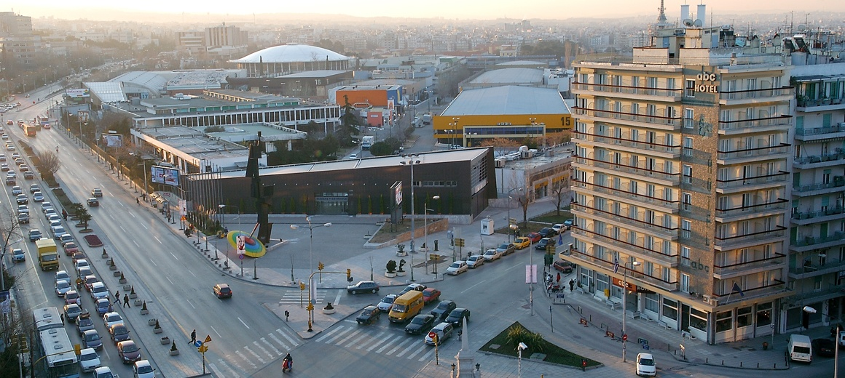
Address: | Aggelaki 41  54621 Thessaloniki-Greece
Tel.: | 2310 265421
E-mail: | info@hotelabc.gr
Website: | https://www.hotelabc.gr/
Distance from Macedonia International Airport: | 15 km
Ways of transportation from the airport to the hotel: | - By car: 30-40min  - By taxi: 30-40min  - By public bus:Bus line N.78, bus stop "Χ.Α.Ν.Θ"(chanth) is 550 meters from the hotel (8min)
ACCOMMODATION COST  To book your room please call 0030 2310 265421 or send your request atinfo@hotelabc.gr  Special Event Code: Greek Serbian Business Forum 2018 | Single room from 55Ε  Double room from 68E

